**CGW STATUS REPORT**

**PHASE 1: DISPLAY INVOICE TABLE**

**Scenario: Using the sales cloud, the teacher will plan the workshop bookings along with the necessary SKUs for the workshop.**

**Opportunity:** Store details for the workshop.

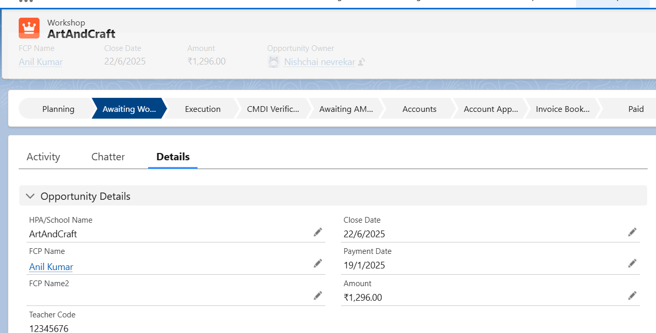

Day 1-Phase 1-Ayesha-1

**Workshop Article**: To Store Workshop SKU Details

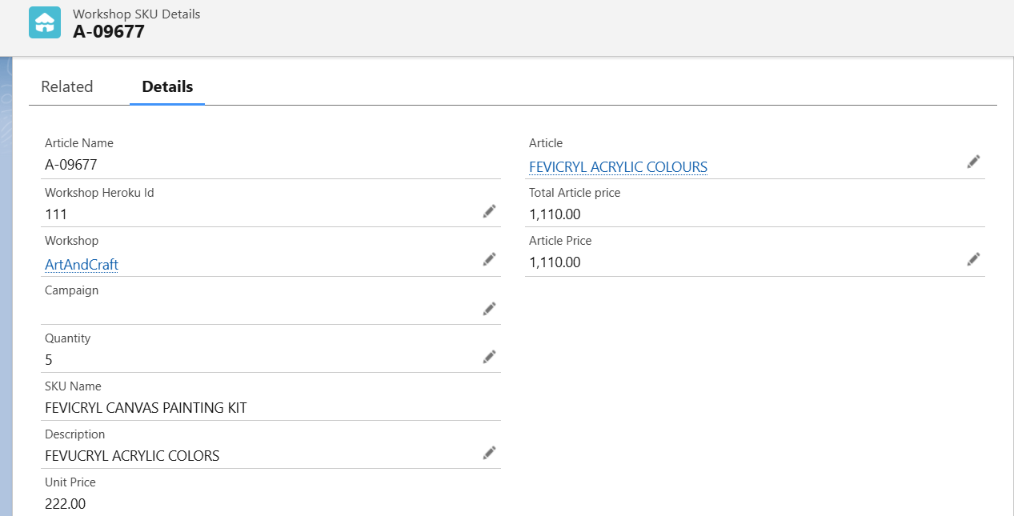

Day 1-Phase 1-Ayesha-2

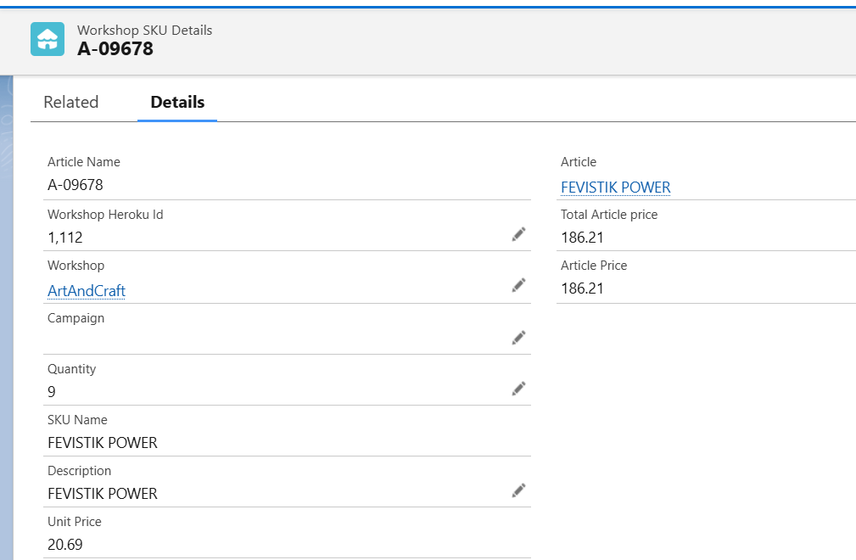

Day 1-Phase 1-Ayesha-3

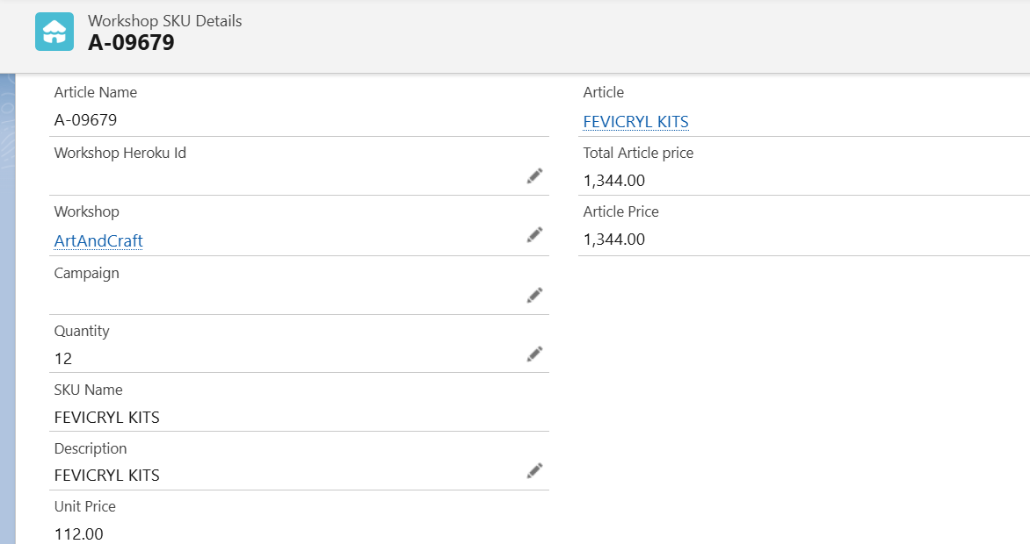

Day 1-Phase 1-Ayesha-4

**Invoice Details Button:**

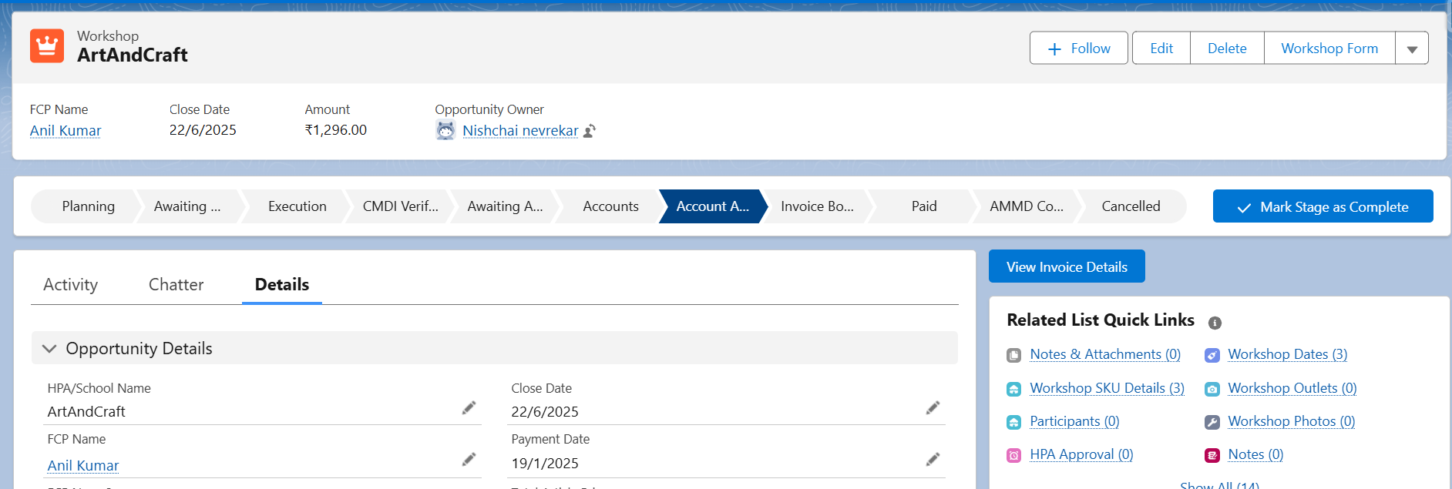

Day 1-Phase 1-Ayesha-5

**URL**:

url = `/apex/InvoiceDetails?origin_record=${this.recordId}` +

              `&account=${this.data[0].account}` +

              `&invoice_date=${this.data[0].invoice_date}` +

              `&invoice_due_date=${this.data[0].invoice_due_date}` +

              `&child_relationship_name=${this.data[0].child_relationship_name}`;

    this.data.forEach((item, index) => {

        url += `&line_item_description_${index}=${item.line_item_description}` +

               `&line_item_quantity_${index}=${item.line_item_quantity}` +

               `&line_item_unit_price_${index}=${item.line_item_unit_price}`;

    });

**Invoice Details Page:**

When we click the invoice details button, a new page will open, displaying the details below.

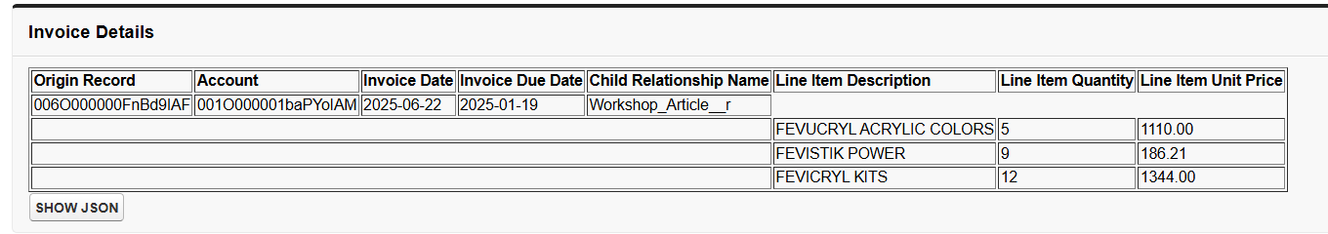

Day 1-Phase 1-Ayesha-6

**Invoice Objects and Fields:**

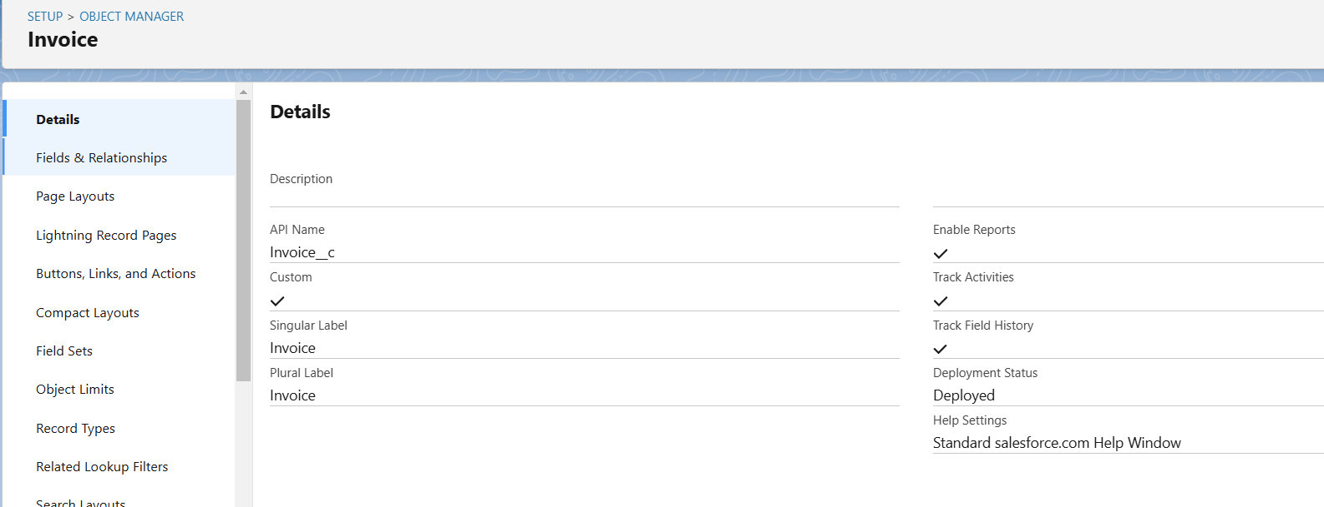

Day 1-Phase 1-Ayesha-7

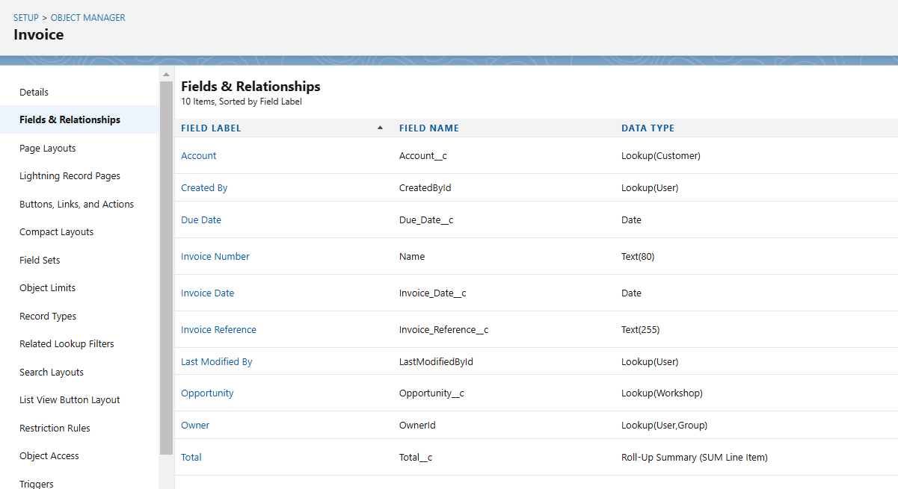

Day 1-Phase 1-Ayesha-8

**Line Item Objects and Fields:**

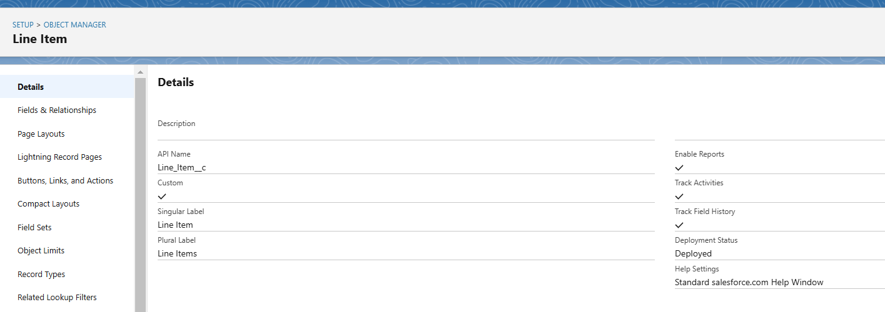

Day 1-Phase 1-Ayesha-9

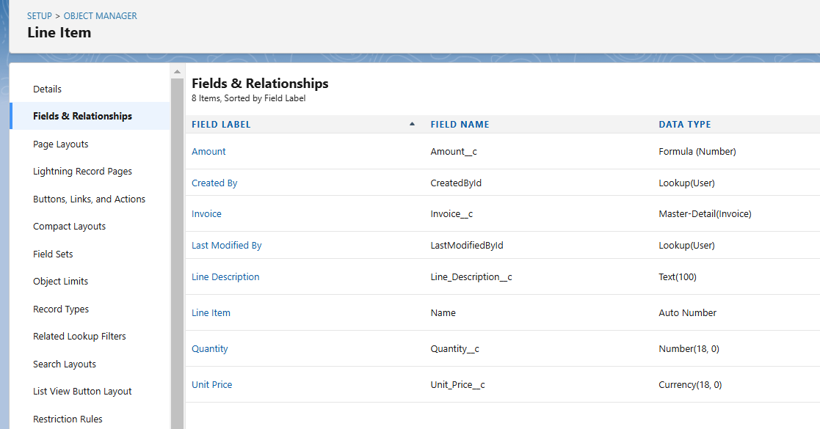

Day 1-Phase 1-Ayesha-10

**PHASE 2: Display JSON**

When the "Show JSON" button is clicked, a new page will open displaying the JSON structure.

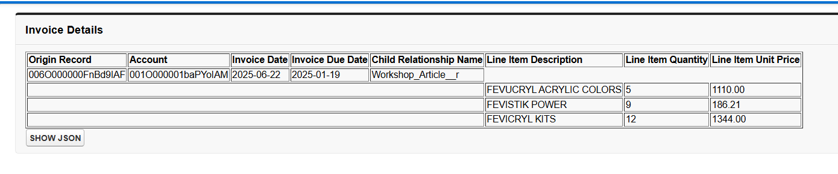

Day 1-Phase 2-Ayesha-11

JSON structure:

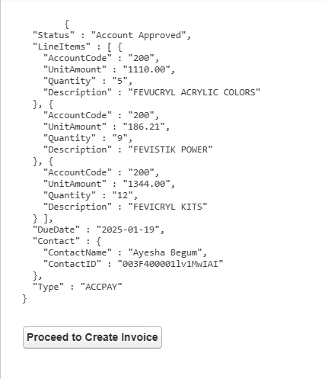

Day 1-Phase 2-Ayesha-12

**PHASE 3: CREATE INVOICE AND LINE ITEMS**

When we click the "Proceed to Create Invoice" button, invoice and line item records will be created, and we will be redirected to the invoice page.

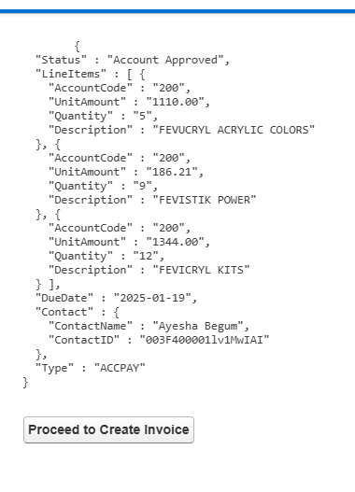

Day 1-Phase 3-Ayesha-13

**Invoice Records**

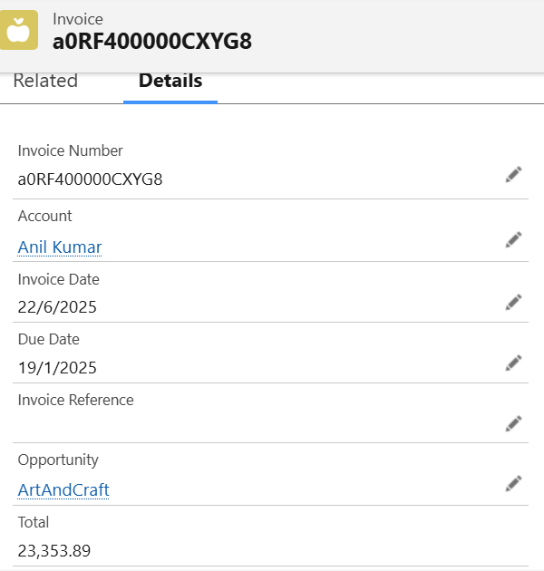

Day 1-Phase 3-Ayesha-14

**Line Item Records**

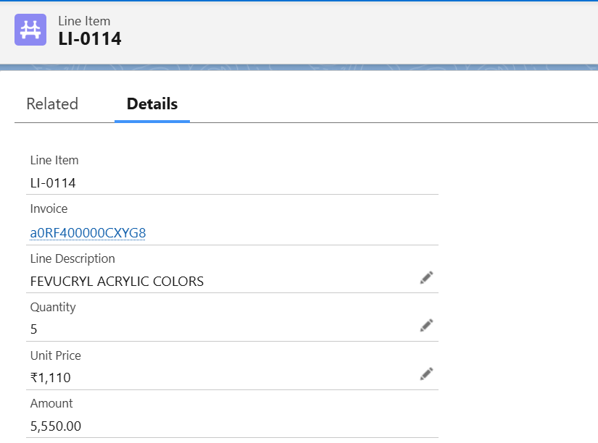

Day 1-Phase 3-Ayesha-15

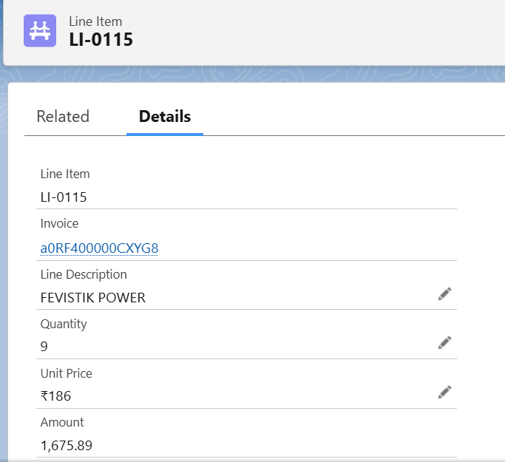

Day 1-Phase 3-Ayesha-16

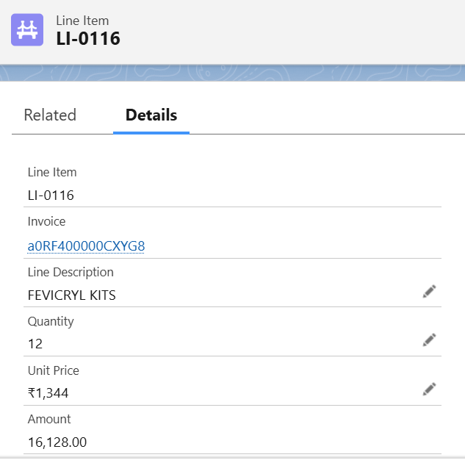

Day 1-Phase 3-Ayesha-17